**Assignment-Courier Management System**

**Task1 Database Design:**

1. Design a SQL schema for a Courier Management System with tables for Customers, Couriers, Orders, and Parcels. Define the relationships between these tables using appropriate foreign keys.

Ans)

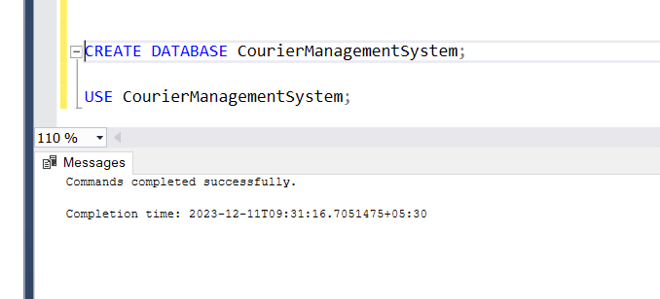

1. Requirements: • Define the Database Schema • Create SQL tables for entities such as User, Courier, Employee, Location,Payment • Define relationships between these tables (one-to-many, many-to-many, etc.).

Ans)

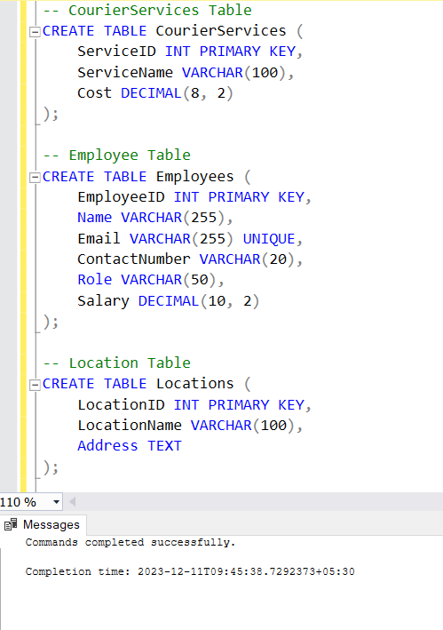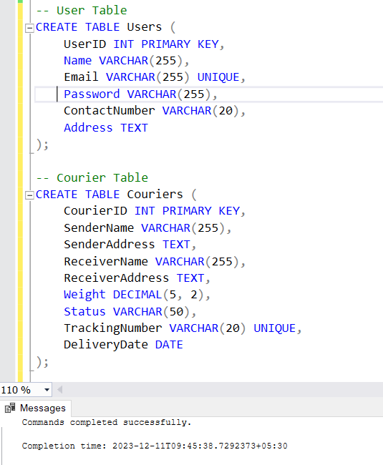

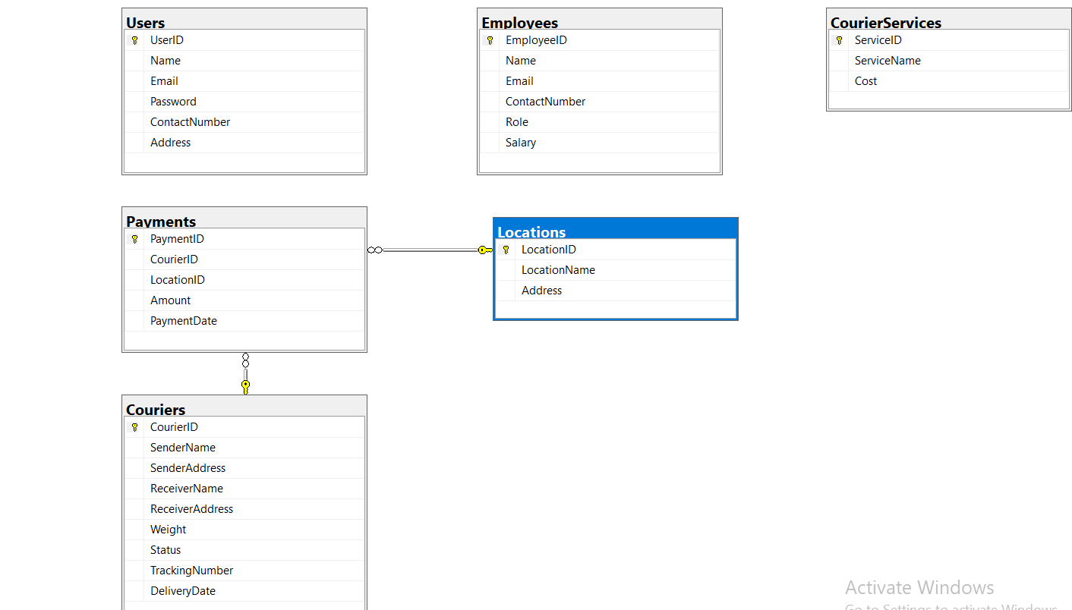

1. Populate Sample Data • Insert sample data into the tables to simulate real-world scenarios.

Ans)

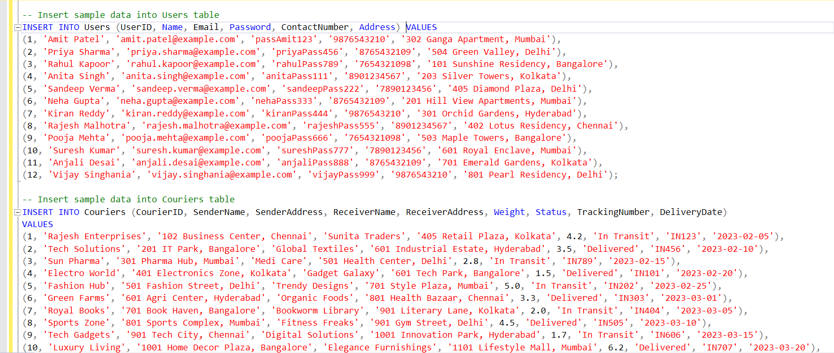

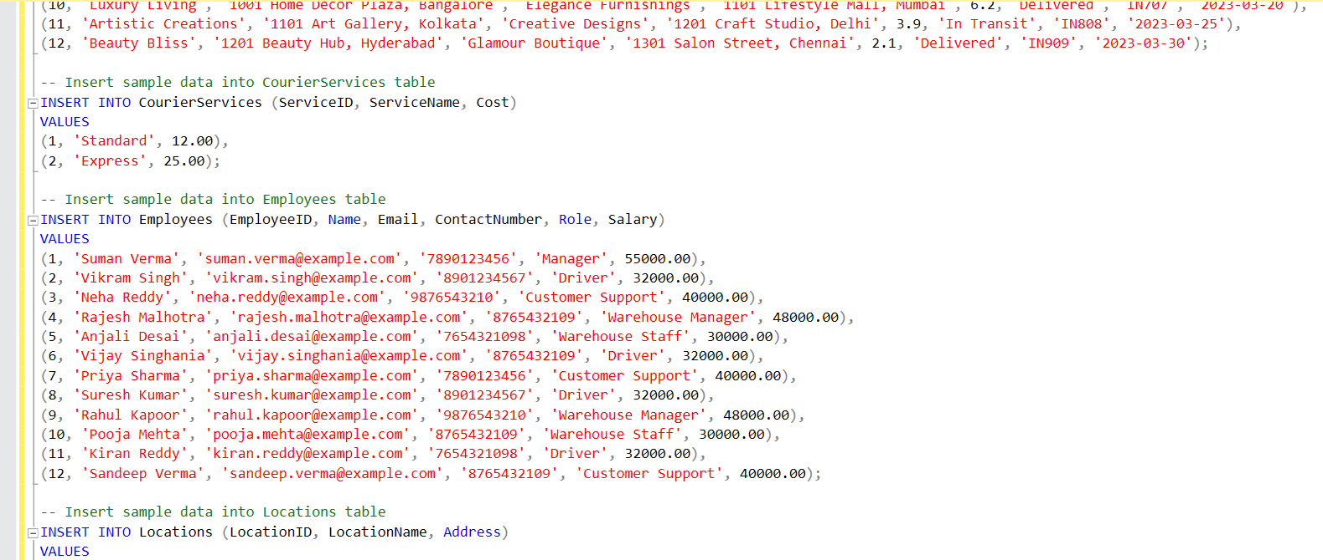

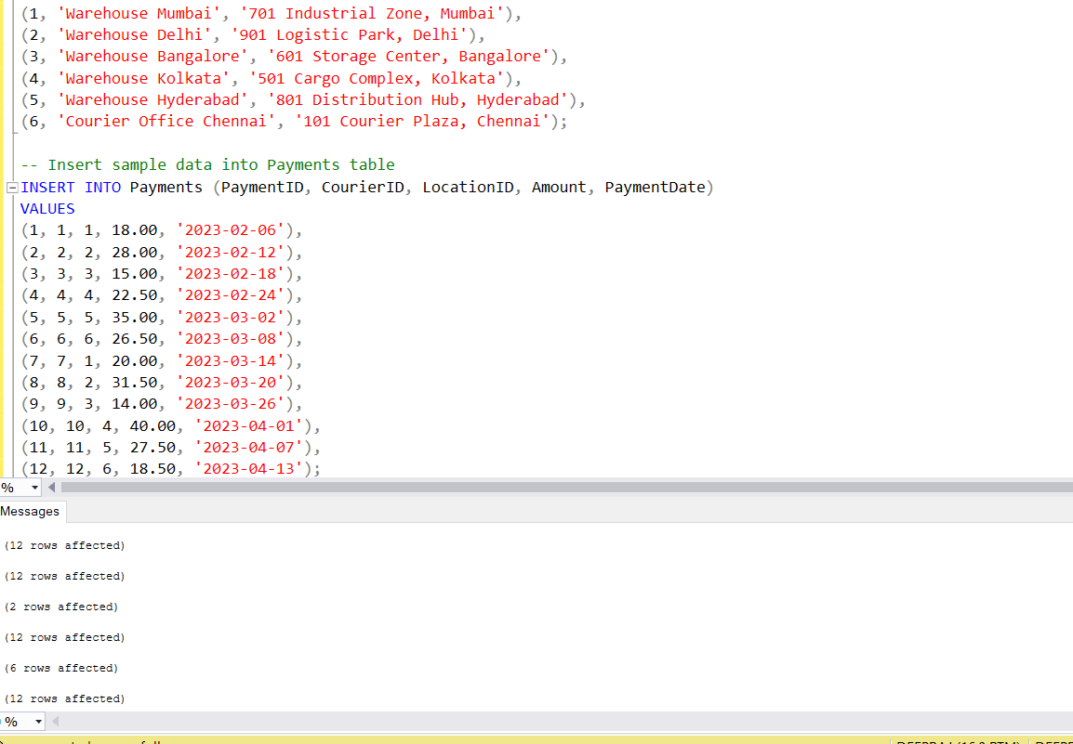

**Task 2: Select,Where**

Solve the following queries in the Schema that you have created above

1. List all customers:

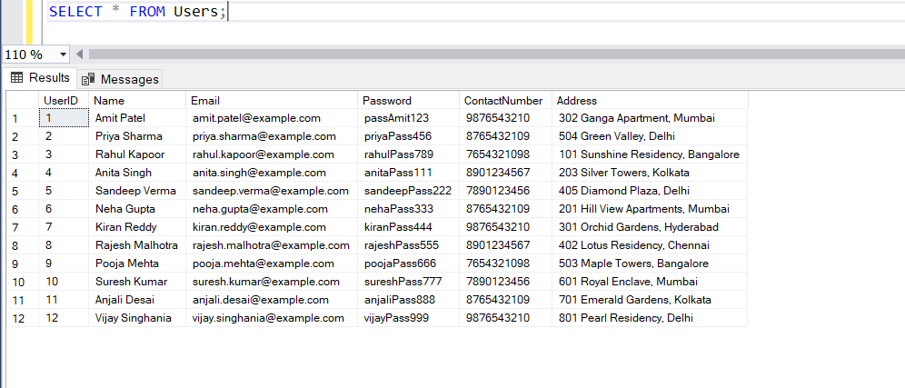

2. List all orders for a specific customer:

3. List all couriers:

4. List all packages for a specific order: 5. List all deliveries for a specific courier: 6. List all undelivered packages: 7. List all packages that are scheduled for delivery today: 8. List all packages with a specific status: 9. Calculate the total number of packages for each courier. 10. Find the average delivery time for each courier 11. List all packages with a specific weight range: 12. Retrieve employees whose names contain 'John' 13. Retrieve all courier records with payments greater than $50.